Expression Language (EL) in JSP-

The **Expression Language** (EL) simplifies the accessibility of data stored in the Java Bean component, and other objects like request, session, application etc.

There are many implicit objects, operators and reserve words in EL.

It is the newly added feature in JSP technology version 2.0.

### **Syntax for Expression Language (EL)**

${ expression }

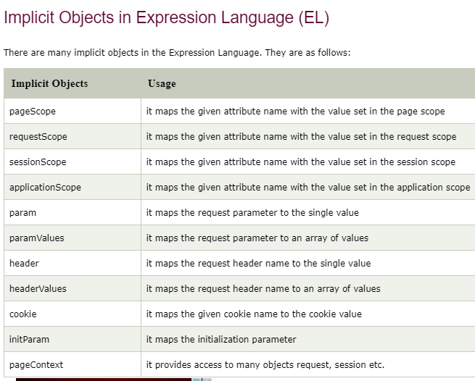

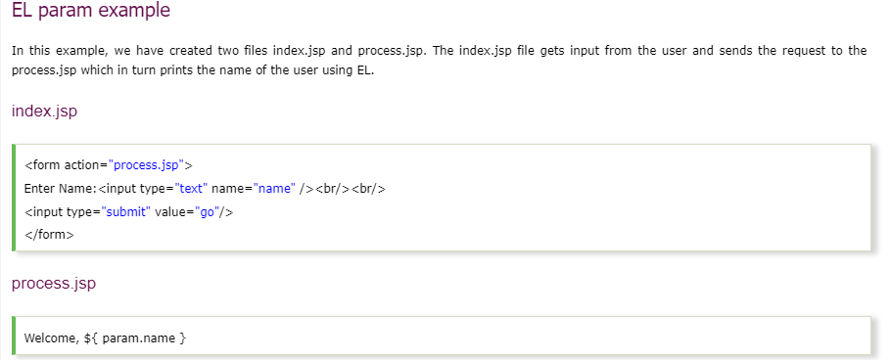

|  |
| --- |
| <%@ page language=*"java"* contentType=*"text/html; charset=ISO-8859-1"*  pageEncoding=*"ISO-8859-1"*%>  <!DOCTYPE html PUBLIC "-//W3C//DTD HTML 4.01 Transitional//EN" "http://www.w3.org/TR/html4/loose.dtd">  <html>  <head>  <meta http-equiv=*"Content-Type"* content=*"text/html; charset=ISO-8859-1"*>  <title>Insert title here</title>  </head>  <form action=*"process.jsp"*>  Enter Name:<input type=*"text"* name=*"name"* /><br/><br/>  <input type=*"submit"* value=*"go"*/>  </form>  </body>  </html> |

### **EL sessionScope example-**

In this example, we printing the data stored in the session scope using EL. For this purpose, we have used sessionScope object.

PROCESS.jsp



**Index.jsp**

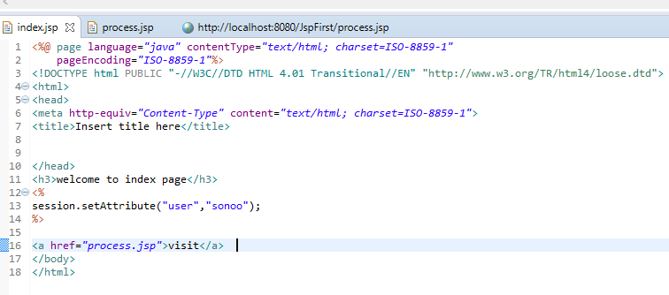

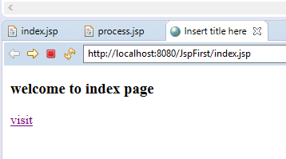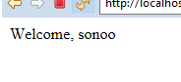

### **EL cookie example-**

Index.jsp

|  |
| --- |
| <h1>First JSP</h1>  <%  Cookie ck=**new** Cookie("name","abhishek");  response.addCookie(ck);  %>  <a href=*"process.jsp"*>click</a> |

Process.jsp

|  |
| --- |
| Hello, ${cookie.name.value} |

